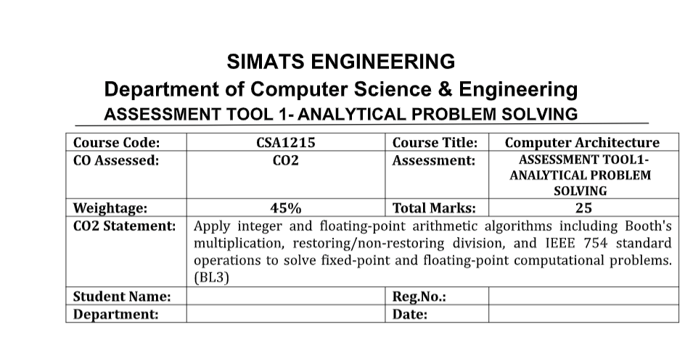
NAME : ROSHAN K
REG NO: 192425014
DEPARTMENT: AI & ML
DATE : 03-08-2026

1. Signed 8-bit Arithmetic Using 2's Complement (+45 and −23)
Step 1: Convert Decimal to Binary
+45
45 = 00101101
−23
First convert +23:
23 = 00010111
Find 2's complement:
1's complement = 11101000
Add 1 = 11101001
So,
−23 = 11101001

(A) Addition: +45 + (−23)
00101101 (+45)
+ 11101001 (−23)
------------
00010110
Discard the carry out.
Result = 00010110 = +22
Verification
45 + (−23) = 22 ✓
Overflow Check
Overflow occurs only if:
- Positive + Positive = Negative
- Negative + Negative = Positive
Here,
Positive + Negative
Overflow does not occur.
Another method:
Carry into MSB = Carry out of MSB
Since both are equal,
Overflow = No

(B) Subtraction: +45 − (−23)
Subtracting a negative means adding its positive.
Find +23
00010111
Now,
00101101
+ 00010111
------------
01000100
01000100 = 68
Verification
45 − (−23) = 68 ✓
Overflow Check
Operands are positive.
Result is also positive.
No overflow

Processor Overflow Detection
A processor checks overflow using
Overflow = Carry into MSB XOR Carry out of MSB
If XOR = 1
Overflow occurred.
Otherwise,
No overflow.

Final Answers
Addition
+45 + (−23) = +22
Binary = 00010110
Overflow = No
Subtraction
+45 − (−23) = +68
Binary = 01000100
Overflow = No

2. 4-bit Carry Look-Ahead Adder (CLA)
Assume
A = 1011
B = 0110
Cin = 0

Step 1: Generate (G) and Propagate (P)
Formula
Gi = Ai × Bi
Pi = Ai ⊕ Bi
Bit | A | B | G | P
0 | 1 | 0 | 0 | 1
1 | 1 | 1 | 1 | 0
2 | 0 | 1 | 0 | 1
3 | 1 | 0 | 0 | 1

Step 2: Carry Equations
C1 = G0 + P0C0

C2 = G1 + P1G0 + P1P0C0

C3 = G2 + P2G1 + P2P1G0 + P2P1P0C0

C4 = G3 + P3G2 + P3P2G1 + P3P2P1G0 + P3P2P1P0C0
All carries are calculated simultaneously.

Step 3: Sum
Si = Pi XOR Ci

Ripple Carry Delay
Carries move one stage at a time.
Bit0 → Bit1 → Bit2 → Bit3
Delay
≈ 4 gate delays

CLA Delay
Carries computed together.
Delay ≈ 2 gate delays

Comparison
Ripple Carry | Carry Look Ahead
Carry generated sequentially | Carry generated simultaneously
Slow | Fast
Simple hardware | Complex hardware
Large delay | Very small delay

Why CLA is Faster?
- Carries are predicted before addition.
- No waiting for previous carry.
- Used in modern CPUs for high-speed arithmetic.

3. Booth's Algorithm (−6 × +5)
Multiplicand
M = −6 = 1010
Multiplier
Q = +5 = 0101
Initialize
A = 0000
Q = 0101
Q−1 = 0

Rules
Q0Q−1 | Operation
00 | No operation
11 | No operation
01 | A = A + M
10 | A = A − M
After every step
Arithmetic Right Shift

Cycle 1
Q0Q−1 = 10

A = A − M
Shift

Cycle 2
Q0Q−1 = 11

No operation
Shift

Cycle 3
Q0Q−1 = 01

A = A + M
Shift

Cycle 4
Q0Q−1 = 10

A = A − M
Shift

Final Result
11100010
Decimal
−30
Verification
−6 × 5 = −30 ✓

Advantages
- Handles positive and negative numbers directly.
- Reduces additions for consecutive 1s.
- Faster than ordinary shift-add multiplication.

4. Division (13 ÷ 3)
Dividend = 1101
Divisor = 0011
Expected
Quotient = 4
Remainder = 1

(A) Restoring Division
Algorithm
- Shift left
- Subtract divisor
- If remainder negative
  - Restore remainder
  - Quotient bit = 0
- Else
  - Quotient bit = 1

Result
Quotient = 0100 (4)

Remainder = 0001 (1)

(B) Non-Restoring Division
Algorithm
- Shift left
- If previous remainder positive
  - Subtract divisor
- If previous remainder negative
  - Add divisor
- Restoration only once at the end (if needed)

Result
Quotient = 0100

Remainder = 0001

Comparison
Restoring | Non-Restoring
Restores remainder every negative step | No immediate restoration
More arithmetic operations | Fewer operations
Slower | Faster
Simple logic | More efficient

Why Non-Restoring is Preferred?
- Eliminates repeated restore operations.
- Fewer additions/subtractions.
- Higher execution speed.
- Widely used in modern processors.

5. IEEE 754 Floating Point (−13.25)

Step 1: Decimal to Binary
13 = 1101

0.25 = 0.01
Therefore
13.25 = 1101.01₂
Normalize
1.10101 × 2³

Single Precision (32-bit)
Sign
Negative
S = 1
Exponent
Bias = 127
3 + 127 = 130

130 = 10000010
Mantissa
Remove leading 1
10101000000000000000000
Final
1
10000010
10101000000000000000000

Double Precision (64-bit)
Bias
1023
Exponent
3 + 1023 = 1026

1026 = 10000000010
Mantissa
1010100000000000000000000000000000000000000000000000
Final
1
10000000010
1010100000000000000000000000000000000000000000000000

Floating Point Addition
Example
13.25 + 6.5
Step 1
Convert both to IEEE format.
Step 2
Compare exponents.
Step 3
Shift mantissa of smaller exponent.
Step 4
Add mantissas.
Step 5
Normalize result.
Step 6
Round according to IEEE 754 (typically "round to nearest, ties to even").
Step 7
Store sign, exponent, and mantissa.

Precision Issues
Normalization
Ensures the number is stored in the standard form:
1.xxxxx × 2^n
Rounding
Extra bits beyond the mantissa are rounded, which may slightly change the stored value.
Precision Loss
Many decimal fractions (e.g., 0.1) cannot be represented exactly in binary, leading to small approximation errors. Repeated floating-point operations can accumulate these errors.

